Co-Chair  Vernon Sykes, Representative  34th House District | 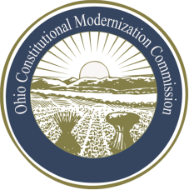 | Co-Chair  William G. Batchelder, Speaker  69th House District
Ohio Constitutional Modernization Commission

OCMC Public Education and Information Committee
Meeting Summary
July 10, 2013

The Committee discussed a proposal from Representative Murray for Commission meetings in other cities. The Committee approved a recommendation that will be presented at the next full Commission meeting.

The Committee discussed a proposal from Representative Murray for Commission protocols regarding testimony. The Committee approved a recommendation that will be presented at the next full Commission meeting.

The Committee reviewed a draft of the Public Service Announcement that will be produced by the Co-Chairs.

The Committee reviewed a draft of the Open Letter from the Co-Chairs and discussed distribution of the Open Letter. The open letter will be distributed at the next full Commission meeting.

The Committee discussed the need for development guidelines for committees for obtaining thorough and comprehensive testimony on recommendations to the full commission. The Committee will continue discussion of this topic in the August meeting.

The Committee discussed the status of updates to the Commission’s web site.

